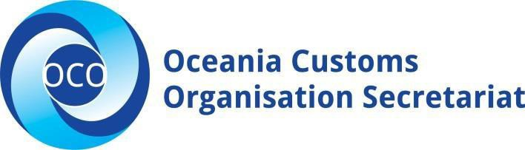

JOB DESCRIPTION – OCO SECRETARIAT
JOB TITLE: | IPR Project Coordinator | AREA: | Operations Division
REPORTS TO: | Operations Manager | LAST REVIEWED: | 01/02/23
EMPLOYMENT TERM: | 3 Years | SALARY BAND: | $FJD30,000

PURPOSE:
The IPR Project Coordinator will coordinate technical assistance and training programs in the field of intellectual property rights border enforcement. The role will work closely with USPTO coordinators and delivering the activities in selected OCO members to ensure the intellectual property rights (IPR) in the Customs legislations are in line with international best practice. This will build capacity and ensure a sound legal framework is in place for Customs to be able to carry out compliance and enforcement work in IPR.

The IPR Project Coordinator will be responsible for the following key tasks:

KEY RELATIONSHIPS:
External | Internal
External  - USPTO (Team Leaders and Specialists)  - Project Consultants  - Auditors  - Other Relevant Stakeholders | - Head of Secretariat  - Operations Manager  - Steering Committee  - OCO FCSM

KEY ACCOUNTABILITIES:
Responsibility | Expected Outcomes
- Project Coordination and Facilitation  - Coordinate progress of members Customs IPR legislation status.  - Organize and coordinate training and assemble IPR Legislation Training Material.  - Organize training material for the model legislative development to be used by participating member countries.  - Co -ordinate with national administrations on their IPR legislative drafting needs.  - Organize webinars and training in consultation with USPTO, OCO and member countries.  - Ensure monitoring and evaluation is conducted for all activities.  - Prepare quarterly acquittals and narrative for IPR project. | - Members are aware of relevant model IPR legislation to be included in their Customs Legislation.  - Members go through the process of incorporating relevant IRP Clauses in their Customs Legislation.  - Organizing training of appropriate members’ personnel in technical IPR Legislative Drafting.  - Public awareness and visibility  - A framework of action regarding Customs IPR legislative work in the Pacific region.  - Timely acquittals and narrative are submitted to the partner for project reconciliation and further funding.

Responsibility | Expected Outcomes
2. Other  Undertaking other relevant activities as deemed necessary for the proper operation of the Project by the OCO Head of Secretariat. | - Other unforeseen duties and responsibilities  are addressed efficiently

PERSON SPECIFICATION:
Mandatory | Desirable
Formal Qualifications
- Undergraduate degree in social sciences. | - Relevant post graduate qualifications
Knowledge and Experience
- Excellent computer skills (MS Access, Excel and Word).  - Experience in project coordination.  - Experience in monitoring and evaluation.  - Experience in organizing and coordinating training.  - Experience in liaising and coordinating with partners be considered an asset.  - Some previous working experience in small Pacific island countries will be considered an asset.  - Proven ability to meet deadlines, and flexible approach to problem solving with demonstrated experience and skill in priority setting. | - Demonstrated experience working with regional funded projects;

Key Skills/Attributes Key Behaviors
Proficient Level  - Project Coordination and Facilitation  - Project planning and reporting  Advanced Level  Record keeping and document  management  Working Knowledge Level  - Roles and mandates of partner regional /international organizations | - Commitment/Personal Accountability  - Professional/Technical Expertise  - Teamwork  - Customer Focus  - Effective Communications & Relationships

KEY RESULTS AREA:

The role of the IPR Project Coordinator encompasses the following major functions or key results area:

- Project Coordination and Facilitation.

AUTHORITIES:
Delegations/Contractual - Commensurate with the OCO Administration Policy, the level of authority to enter into contracts or negotiations on behalf of the organization.

Financial - Delegations in line with the OCO Administration Policy and Finance Policies and
Procedures.

CHANGE TO JOB DESCRIPTION

From time to time it may be necessary to consider changes in the job description in response to the changing nature of the work environment - including technological requirements or statutory changes. Such change may be initiated as necessary by OCO. This Job Description may also be reviewed as part of the preparation for performance planning for the annual performance cycle.

Approved:

Head of Secretariat Date

Employee Date

