SIMRAN SHARIKTA SHIROMANI 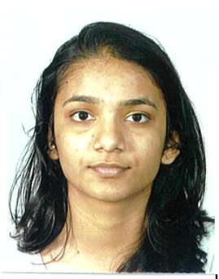  CONTACT  Address:  28 Vuna Rd,  Nabua,  Suva.  Phone:  +679 8088137  Email:  simshiromani@gmail.com  Language:  English  Hindi  SKILLS  - Pay attention to detail  - Inspire professional cooperation intra-company  - Planning and managing events and programs  - Team player and ability to adapt organizational culture  SOFTWARE EXPERIENCE  - Port manager  - Navision  - Proficient with power point (analysis graph) and Excel |  | CAREER OBJECTIVE  Aiming to leverage a proven knowledge of economical and accounting expertise skills to successfully fill the role of a finance professional in your company. Frequently praised as hard-working by my peers, I can be relied upon to help your company achieve its goal.  WORK EXPERIENCE  Feb 2019-Present  Assistant Accounts Officer-Audit, Fiji Ports Terminal Ltd, Suva Fiji  Responsibilities:  - Auditing of the revenue process, the payment process, and the payroll  - Physical verification inventory and fixed assets  - Compliance audits relating to 5s and ISO (QMS. EMS and OHS)  - Timely reporting of audit results and statistical analysis worksheet  - Assisting other audit institutions auditing the company (ISLI , EY & BDO)  - Maintaining a high level of accuracy and confidentiality concerning classified documents.  - Assisting Accounts Receivable, Payroll and Payables department  - Updating and maintaining reports relating to revenue assurance  - Proper documentation of records and filing  - Assistance with the budgeting process  - Petty Cash management  - Bank Reconciliation for FPTL accounts  - Tasks assigned by supervisors (presentation, board papers, awards functions, events at work and others)  Mar 2018-Jul 2018  Assistant Administrative Officer, Tertiary Scholarship and Loans Boards, Suva Fiji  Responsibilities:  - Prepared student allowances and tuition fees  - Updating records in the excel system  - Filing  - Petty cash management  EDUCATION  2015-2019  Bachelor of Commerce, University of South Pacific  GPA: 2.7  2021-still  CPA  ADDITIONAL TRAININGS  ISO Training (9001:2015, 14001:2015, 45001:2018)  Customer Services Training  REFERENCES  - Chandni Kumar  Accountant, Fiji Ports of Terminal Ltd  9907145 -chandani@fijiports.com.fj – Accountant  - Ashneeta Swamy  Accounts Officer- General Ledger, Fiji Ports Terminal Ltd  9706049 – ashneeta@fijiports.com.fj – Accounts Officer  - Shaqeel Hussain  Administrative Officer, Tertiary Scholarship and Loans Board  9274348 – Former Administrative Officer

