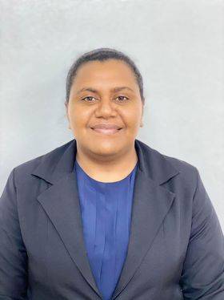**CURRICULUM VITAE**

Ela Lute Tavo-Ratulevu

35 Nayau Street,Samabula.

Email: [ellatavo@yahoo.com](mailto:ellatavo@yahoo.com)

Phone: 8785159

______________________________________________________________

**Resume Summary:**

Law graduate seeking employment opportunity in all areas of employment where I can expand my knowledge and skill set. I am a motivated team player and with proven communications and research skills. I am an eager learner with a goal to continually search out opportunities for myself and career development.

______________________________________________________________  
  
 **Academic Summary:**

* Graduate Diploma in Legal Practice
* Bachelor of Law
* Certificate III in Information System
* Fiji seventh Form Certificate Examination
* Fiji Leaving Certificate Examination.

______________________________________________________________  
  
**Professional Experience:**

**Parliament Intern**

Fiji Parliament- Department of Legislature

* Committees Unit
* Monitoring, Evaluation & Compliance Unit.

**Legal Internship:**

Fiji Independent Commission Against Corruption.

**Internship**

Neel Shivam Lawyers:

* Court observation in the Magistrate Court and High Court.

Independent Legal Service Commission

* Filing of case files and preparation of cases before hearing by the Commissioner.
* Sat in on hearing against legal practitioners that are presided over by the Commissioner.

**Librarian Assistant- Mulomulo Secondary School.**

* Attendant at the schools library.
* Issued books to students
* Annually stock take of the library.

**Employment- Judiciary Department Fiji**

High Court Criminal Registry- Assistant Court Officer-

* Court Interpretation
* Maintaining Judges Court Diary
* Manual Data entry into relevant registers.
* Filing of Case Files
* Attending to over the counter and telephone enquiry by the general public.
* Responding to correspondence where and when necessary.

**Membership/ Affiliation**

Fiji Women Lawyers Association

Participated in the Hibiscus Festival Queens Category

______________________________________________________________  
  
**Skills & Competencies**

MS Office Package (Word, Excel, PowerPoint)

Excellent Communication Skills both written and verbal.

______________________________________________________________

**Reference**:

Ms Koila Kabu

Course Coordiator

Graduate Diploma Legal Practice

ma’imoak@unifiji.ac.fj

Mobile:+679-9774230

Ms Francis Puleiwai

Manager Legal

Legal Department

Fiji Independent Commission Against Corruption.

Email: francis.puleiwai@ficac.org.fj

Phone: 9904990

Mr Savenaca Koro

Senior Committee Clerk

Committees Unit,

Fiji Parliament.

[Savenanca.koro@govnet.gov.fj](mailto:Savenanca.koro@govnet.gov.fj)

Mrs Lois Vakarau

Manager Monitoring, Evaluation and Compliance.

Corporate Division, Parliament of Fiji.

[<lois.vakarau@legislature.gov.fj>](lois.vakarau@legislature.gov.fj)